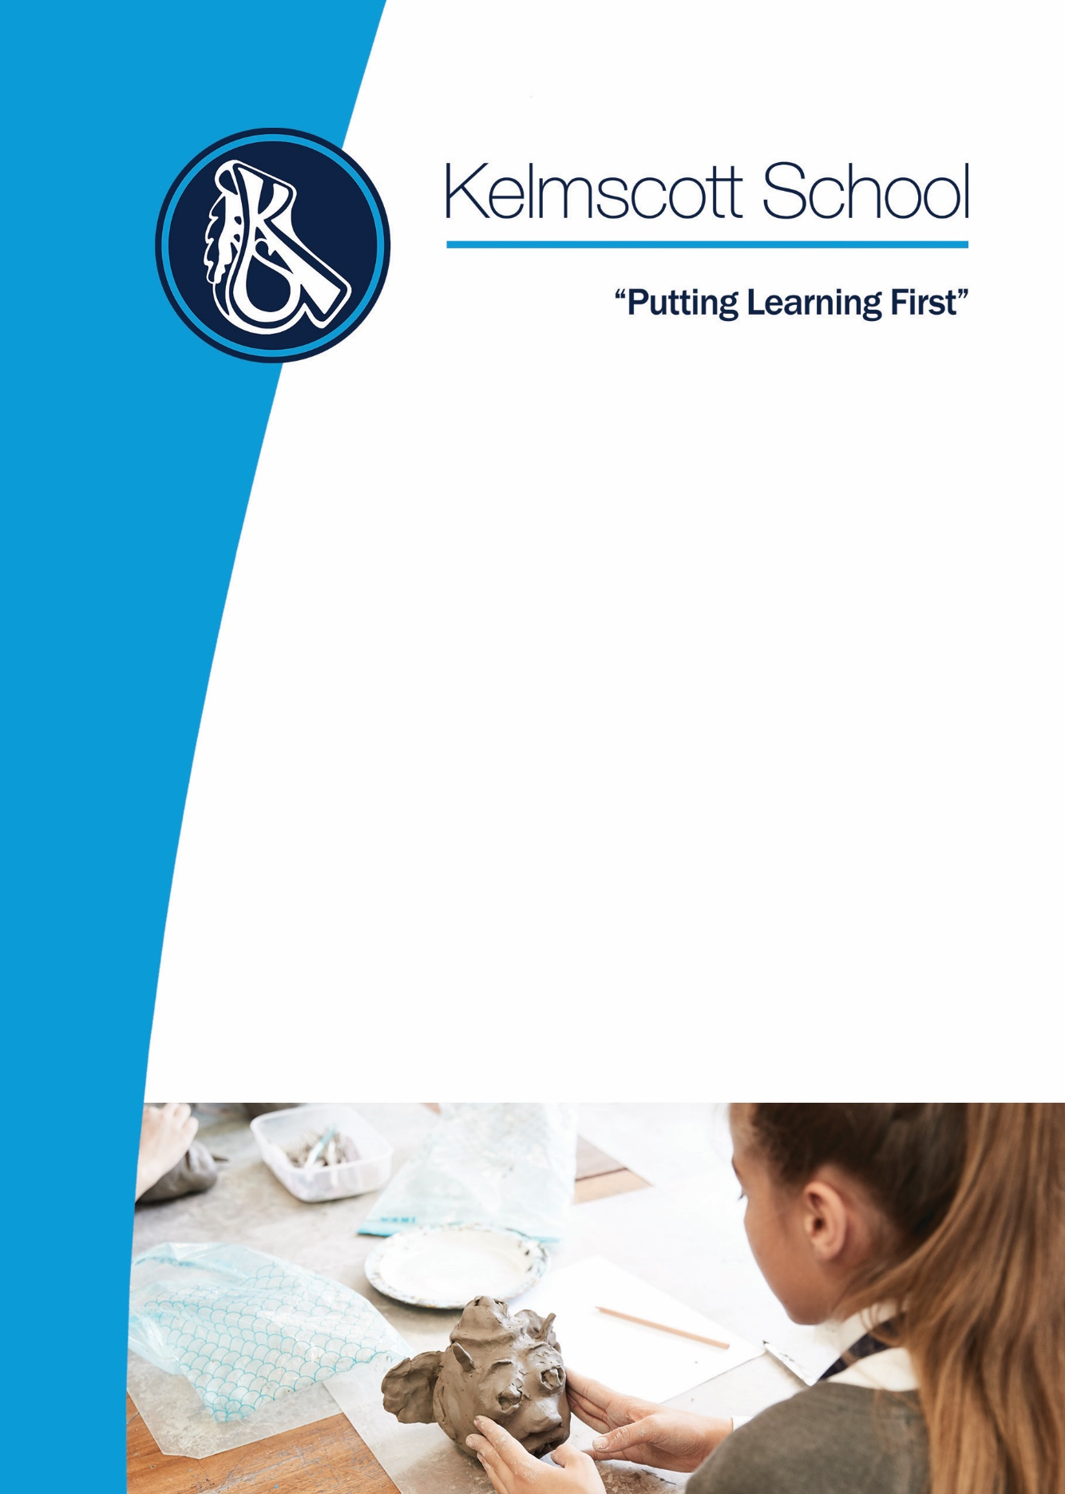
Moving to
Key Stage 4
Options Booklet

2021

Introduction
Until now, choices about what you study have been made for you. However, when you choose your options, you start to take more control – and have more responsibility. This responsibility must be taken very seriously as the subjects you choose to study – and the ones you leave behind – may affect what you can do in the future.

It is time to start thinking about your career. You don’t necessarily need to have a job in mind, just an idea of what you like doing and what you are good at. It can help you if you choose subjects that might be useful, and avoid missing a subject you might need later on. Above all, the decisions should be made in each individual student’s best interest, balancing those subjects that are going to provide a wide range of opportunities further down the line of education and employment, with those that you most enjoy and have a particular ability in.

Choosing your subjects
- English, Maths, Science, RE and core PE are compulsory
- Your choice may be from GCSEs or also from vocational qualifications such as BTECs
- Some may be subjects you don’t know much about - for example, Business Studies

How your option choices may affect your future
A’ Levels
- Some A’ Levels need a GCSE in the same subject - for example, Art or French
- A’ Level Maths requires the GCSE Higher tier
- You need dual award science or separate sciences to study A’ Level sciences

BTECs
- BTEC stands for Business and Technology Education Council and they offer vocational qualifications in areas such as work skills and health and social care
- You can do a BTEC - equivalent to one GCSE - alongside other GCSEs

University
- Most university degrees require at least five good GCSEs including Maths and English – some will accept alternatives like BTECs, others may not – so check course entry requirements carefully
- Primary teaching degrees require GCSE Science as well as Maths and English (plus two others) and some want ‘good’ grades (5 or above) in one of these, and some say a language is ‘desirable’
- A language is also useful for accountancy, air cabin crew, computer games testing, and fashion

Apprenticeships
By taking an apprenticeship you go straight into your chosen career. You get on-the-job training, which gives you the chance to develop skills and gain relevant work experience. Plus, you get a formal qualification at the end of it. This could be a good alternative for you to choose when you finish Kelmscott at 16.

There are three levels of apprenticeship:
- Intermediate apprenticeships - equivalent to 5 GCSEs 9-4
- Advanced apprenticeships - equivalent to 2 A’ Levels
- Higher and degree apprenticeships - equivalent to university level education

The one you choose will depend on your current skills and qualifications. Complete a higher apprenticeship and you will earn a qualification that could be equivalent to a Master's degree. If you lack work experience or basic qualifications, you can also do a traineeship to gain experience before applying for an apprenticeship.

Bear the following in mind when choosing your Options:
- No subjects are ‘easy’ – find out exactly what you will be studying if you are unsure
- Choosing subjects just because your friends are doing them is not a good idea, they may have different aims than you and you may well be put in different sets
GCSE Courses
GCSE stands for the General Certificate in Secondary Education. GCSEs are studied by the majority of students in Years 10 and 11. These courses indicate that a student has achieved a certain level of general education and gives them a route into higher level qualifications such as A’ Levels, BTECs, or a Modern Apprenticeship.

How you will be assessed
The majority of new GCSEs are assessed in examinations at the end of the two-year course. GCSEs are now reported on a grade of 9-1 (see below), with nine being the highest. Those students who do not achieve the standard required for a grade 1 are reported with a ‘U’ (Unclassified).

Note: An option course may not run if there is not enough uptake

The English Baccalaureate
To achieve the EBacc students need to attain:
- A grade 5 or above in English language GCSE and any grade in English literature GCSE
- A grade 5 or above in Mathematics GCSE
- A grade 5 or above in either History or Geography GCSE
- A grade 5 or above in a language GCSE
- A grade 5 or above in Double Award Science, or students need to enter three single sciences and achieve grade 5 or above in at least two of them (the single sciences are Biology, Chemistry, Computer Science and Physics)

A full list of the qualifications that count towards the EBacc is available at GOV.UK

NB: Some Russell Group universities (the top 20 universities in the UK) request that students have a foreign language as entry for all courses

Who to see for advice | What they can help you with
Tutors | General information and advice about careers and options
HOY/AHOY | General information and advice about careers and your option choices
Options Co-ordinator (Ms Thorp) | Advice about picking or changing option subjects
Heads of Department | Information about specific subjects
Careers Advisers | Advice on careers and the qualifications they require
Careers Administrator | Booking an appointment with the Careers Adviser

On the following pages you will find more detailed information about each of the subjects to help inform your choices

The new English exam is now up and running with the current year 11 set to be the third cohort who will sit the AQA exam.
GCSE English

The course is 100% exam-based. There will be no coursework, no early-entries and therefore no re-sits. There are also no tiers of entry, which means that all students will sit the same paper, regardless of ability or need. This is an EBacc subject.

The English Language exam is made up of 2 papers. One focuses on fiction and descriptive writing; the other focuses on non-fiction and argumentative/persuasive writing. Both exams are 1 hour and 45 minutes long. An ability to read is vital. Anyone with a reading age below 15 years-old will struggle.

The English Literature exam is made up of 2 exam papers. Students will be examined on The Strange Case of Dr. Jekyll and Mr. Hyde, An Inspector Calls, Macbeth, Power and Conflict poetry and Unseen Poetry. One paper is 90 minutes and the other is 2 Hours 15 minutes. Students will NOT be allowed to take any of the texts into the exam with them. Therefore, they MUST know these texts very well and read them independently more than once. The texts are very challenging and students with a low reading age will struggle to access them. Therefore, it is vital that all students continue to improve their reading ages.

Please email Mr Hogg the Head of English or your English teacher for more information

GCSE Mathematics

In line with the new GCSE specifications, GCSE Mathematics is now harder and more demanding for all students.
The major changes to the curriculum include an increase in the volume and demand of subject content as well as an increase in examination time and a new grading structure.

Fewer marks will be awarded at the lower grades and more marks at the higher grades. There will be a greater emphasis on problem solving and mathematical reasoning with more marks being allocated to these higher order skills.

The full examination will comprise of three 90 minute papers with each paper carrying a weighting of 33.3% at both Foundation and Higher tiers. All exams will be sat at the end of the course, with the students sitting one non- calculator and two calculator papers.

The new grading system will of course be adopted, with grades 9 to 1 being awarded instead of the A*- G grading system. The foundation tier will see grades being awarded from 5-1 and the Higher tier grades 9-4. Grades 4-5 are the overlap grades between Foundation & Higher tiers, so common questions targeted at these grades will appear on both papers.

Please email Mr Rumjon or your maths teacher for more information

GCSE Religious Studies

All year 10 and year 11 students currently study GCSE Religious Studies full course. The students at Kelmscott School will begin their Religious Studies GCSE in May of Year 9, so they will have two solid years of specific and intensive study to prepare them for their Religious Studies GCSE. We use Edexcel as our exam board. The course focuses on a study of Christianity and Islam and their impact on society’s belief and practices.
GCSE Religious Studies: Aims
This course of study encourages students to:
- Objectively analyse issues surrounding belief and lack of belief in God, issues connected to life, death and the afterlife and how it impacts on people’s everyday lives
- Discuss critically the impact and role that religion has on issues within society, for example: marriage, family, community cohesion, law and politics, medicine, the environment and crime and punishment
- Develop a range of skills, knowledge and understanding necessary for progression to further learning

GCSE Religious Education: Topics
- Christian and Muslim beliefs
- Matters of life and death
- Marriage and the family
- Living a Christian life/Living a Muslim life
- Peace and conflict on a world scale
- Crime and punishment

How is the course assessed?
- GCSE Religious Education full course has eight units which will be examined in two exams as a written paper. The exams are 1 hour 45 minutes

What careers does this course lead to?
Students who do Religious Education at Key Stage 4 can then study AS and Advanced GCE in Religious Studies, Philosophy and a range of other humanities subjects such as Sociology, History, Geography and English. The course gives students the opportunity to develop skills in evaluation and consideration of issues from a range of perspectives. These skills are highly valued by a range of employers. Students could potentially go on to have a career in theology (religious leader), teaching, counselling, writing, television or radio broadcasting, social work, philosophy, politics and journalism.

Please email Ms Reid or Ms Passa for more information

GCSE Combined Science: Trilogy

Exam board: AQA
This specification is designed to be taken over two years. This is a linear qualification. In order to achieve the award, students must complete all assessments at the end of the course and in the same series.

The qualification will be graded on a 17-point scale: 1–1 to 9–9 – where 9–9 is the best grade. A student taking Foundation Tier assessments will be awarded a grade within the range of 1–1 to 5–5. Students who fail to reach the minimum standard for grade 1–1 will be recorded as ‘U’ (unclassified) and will not receive a qualification certificate. A student taking Higher Tier assessments will be awarded a grade within the range of 4–4 to 9–9. A student sitting the Higher Tier who just fails to achieve grade 4–4 will be awarded an allowed grade 4–3. Students who fail to reach the minimum standard for the allowed grade 4–3 will be recorded as ‘U’ (unclassified) and will not receive a qualification certificate.

Aims
Courses based on this specification should encourage students to:
- develop scientific knowledge and conceptual understanding of science
- develop understanding of the nature, processes and methods of science
- develop and learn to apply observational, practical, modelling, enquiry and problem-solving skills, both in the laboratory, in the field and in other learning environments
- develop their ability to evaluate claims based on science through critical analysis of the methodology, evidence and conclusions, both qualitatively and quantitatively

Topics
Biology - Cell biology, organisation, infection and response, bioenergetics, homeostasis and response, inheritance, variation and evolution, ecology

Chemistry - Atomic structure and the periodic table, bonding, structure, and the properties of matter, quantitative chemistry, chemical changes, energy changes, the rate and extent of chemical change, organic chemistry, chemical analysis, chemistry of the atmosphere, using resources

Physics - Forces, energy, waves, electricity, magnetism and electromagnetism, particle model of matter, atomic structure

How is the course assessed?
There are six papers: two biology, two chemistry and two physics. Each paper has:
- Written exam: 1 hour 15 minutes
- Foundation and Higher Tier
- 70 marks
- 16.7% of GCSE

What careers does this course lead to?
Courses based on this specification form a firm basis for level 3 courses in the sciences such as AS and A Level Biology, Chemistry and Physics.

Please email Mr Wahid for more information

GCSE Triple Science

This specification is one of a suite of GCSE Science specifications offered by AQA. The specification leads to three single awards: GCSE Biology, GCSE Chemistry and GCSE Physics.

Each of these single award GCSEs would provide the basis for the study of the corresponding GCE science. Each of these sciences emphasise explaining, theorising and modelling in science.

Aims
Courses based on this specification should encourage students to:
- develop scientific knowledge and conceptual understanding of science
- develop understanding of the nature, processes and methods of science
- develop and learn to apply observational, practical, modelling, enquiry and problem-solving skills, both in the laboratory, in the field and in other learning environments
- develop their ability to evaluate claims based on science through critical analysis of the methodology, evidence and conclusions, both qualitatively and quantitatively

GCSE Biology:
Topics
Cell biology, Organisation. Infection and response, Bioenergetics, Homeostasis and response, Inheritance, variation and evolution, Ecology

How is the course assessed?
There are two papers. Each paper has:
- Written exam: 1 hour 45 minutes
- Foundation and Higher Tier
- 100 marks
- 50% of GCSE

GCSE Chemistry:
Topics
Atomic structure and the periodic table, Bonding, structure, and the properties of matter, Quantitative chemistry, Chemical changes, Energy changes, The rate and extent of chemical change, Organic chemistry, Chemical analysis, Chemistry of the atmosphere, Using resources

How is the course assessed?
There are two papers. Each paper has:
- Written exam: 1 hour 45 minutes
- Foundation and Higher Tier
- 100 marks
- 50% of GCSE

GCSE Physics:
Topics
Forces, Energy, Waves, Electricity, Magnetism and electromagnetism, Particle model of matter, Atomic structure, and Space physics

How is the course assessed?
There are two papers. Each paper has:
- Written exam: 1 hour 45 minutes
- Foundation and Higher Tier
- 100 marks
- 50% of GCSE

What careers does this course lead to?
A course based on this specification provides a worthwhile course for candidates of various ages and from diverse backgrounds in terms of general education and lifelong learning. It will follow naturally from a course based on the programme of study for KS3 Science. From a GCSE course, students could progress to GCE Biology, Chemistry and Physics.

Students can then progress onto science based careers for example: Doctor, Nurse, Dentist, Vet, Science Teacher, Engineer, Science Researcher or Pilot.

Pathway: Blue
Please email Mr Wahid for more information
GCSE Geography

OCR Geography Syllabus B
There are three sections to the syllabus:
- Our natural world (includes global hazards, changing climate, landscapes, ecosystems)
- People and Society (includes urban areas, development, UK in the 21 century, resources)
- Geographical exploration (includes fieldwork and a decision making exercise. Two fieldtrips that give students information to answer the exam skills-based questions)

There are three written papers, 1 hour 15 minutes for the first two sections and 1 hour 30 minutes for the third section.

This is an Ebacc subject, literacy based with numeracy content. Students have to show initiative and independence when completing fieldwork tasks and questions.

At college, Geography forms part of pathways with the sciences (through the environment), with humanities to subjects like law and journalism, or economics with its focus on global patterns and the future.

Pathway: Red
Please email Mr Paine for more information

GCSE Modern History

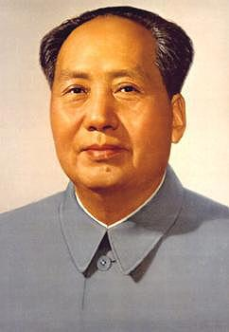
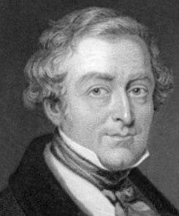
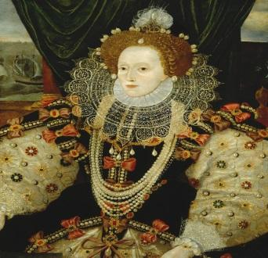

The History GCSE course teaches students about some of the key events that have shaped Britain and the modern world. The course focuses on teaching students how to research, support and develop an argument and to interpret and question the world around them. Further, in the History department we try to include off-site teaching and trips into our courses, wherever possible.

Students follow a course in ‘The Making of the Modern World’. Specifically, students will study:
- Crime and Punishment through Time (1000-present)
- Early Elizabethan England (1558-88)
- Superpower Relations and the Cold War (1943-91)
- Mao’s China (1945-76)

How is this course assessed?
- 100% of the grade for this course will be from the exams taken at the end of year 11.
- There will be three papers sat:
- Paper 1 worth 30% (Crime and Punishment),
- paper 2 worth 40% (Cold War and Elizabethan England)
- Paper 3 worth 30% (Mao’s China).

What careers does this course lead to?
A GCSE in history is good preparation for ‘AS’ and ‘A’ Levels in History, Humanities and Law.

At the end of this course, students can go on to study a History-related course at Sixth form or college and then progress on to a career using the analytical skills developed, for example by studying law, media, politics, archaeology, social work and teaching.

Finally, don’t forget Prime Ministers Gordon Brown and Tony Blair both had degrees in History!

Pathway: Red
Please email Ms Briand, Mr Yilmaz or Mr Revis for more information

GCSE Ancient History

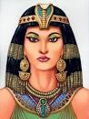
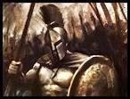
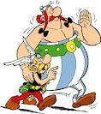

The GCSE course in Ancient History will be looking at ancient Roman and Greek civilizations and how they interacted with societies around them. We hope it will also incorporate learning at heritage sites locally, nationally and maybe even internationally.

Specifically, this course will be looking at ancient artefacts and documents that re-awaken students’ awareness of the world of Julius Caesar and Cleopatra, the Romans, Alexander the Great and the Persian Empire which they may previously have studied at Key Stage 2.

This GCSE is recognised as a leading academic qualification.

This course will involve handling original documents; this requires the utilisation of quite advanced skills. Students will find it advantageous to be working to at least a grade 5 or above in both History and English with a reading age of 15 years old or above to best tackle this enjoyable but challenging course. Students are advised to speak to their History teacher and undertake some preparatory reading before choosing this option.

How is the course assessed?
- Over years 10 and 11 students will prepare for written exams at the end of year 11. The written exams will focus on stories about the Origins of Rome, Cleopatra and Julius Caesar, Classical Greece and the Persian Empire
- The exam is divided in two – Component 1: Rome and its neighbours, and Component 2: Greece and Persia
- Both exams are worth 50% of their total GCSE grade

What careers does this course lead to?
A qualification in the Classics is a pre-requisite for many courses at the elite universities and is excellent preparation for professional employment and further academic study.

Note: This course would be ideal for students thinking about taking History, Literature or Archaeology at college

Pathway: Blue
Please email Ms Briand or Mr Yilmaz for more information
GCSE Spanish

GCSE Spanish teaches students how to speak, read and write in Spanish. This is an Ebacc subject. The course covers topics relating to personal life, family, home, leisure, school, work, holidays and personal interests. It gives students an insight into the culture of Spain and the countries of Latin America. GCSE Spanish also prepares students for travel, visits to, and work in Spanish speaking countries. Students develop fluency and a greater depth of knowledge of the Spanish language through practising their listening, speaking, reading and writing skills. Being able to communicate in a foreign language is a key skill which has become an entry requirement for some professions and universities.

It is expected that by the end of year 11 students should be able to take part in discussions in Spanish where opinions are shared.

Students will need to buy a Spanish-English bilingual dictionary for use in lessons, at home and with their coursework.

We organised a very successful study trip to Barcelona for GCSE students in 2016 and we hope to repeat this in the future.

How is the course assessed?
- The examinations for listening, reading, speaking and writing take place at the end of year 11

What careers does this course lead to?
A GCSE in Spanish is a good preparation for A’ Level Spanish or for anybody considering a career in travel, leisure & tourism, business, law, IT, engineering, retailing, journalism, medical, fashion, politics and the arts.

At the end of the course students can go on to study Spanish at college and then progress on to a career using Spanish, e.g. travel agent, tour organiser, air line worker, airport official, wine and food importer, art gallery manager, international events organiser, diplomat or Spanish teacher.

Employers value workers who can speak a foreign language. Some Russell Group universities (the top 20 universities in the UK) request a foreign language as entry for all courses. A language is a skill for life!

Pathway: Red
Please email Ms Thorp or Mr Ravoux for more information

GCSE French

GCSE French teaches students how to speak, read and write in French. This is an Ebacc subject. The course covers topics relating to personal life and interests, as well as preparing students for travel, visits and work in French speaking countries. It gives students an insight into the culture of France and francophone countries. Students are also prepared to live in a multi-cultural society where communication in different languages is a key skill for employment and for entrance to some universities. Students develop fluency and a greater depth of knowledge of the French language through practising their listening, speaking, reading and writing skills.

It is expected that by the end of year 11 students should be able to take part in discussions in French where opinions are shared.

Students benefit from developing their listening and speaking skills by working with a French assistant.

Students will need to buy a French-English bilingual dictionary for use in lessons, at home and with their coursework.

How is the course assessed?
- The examinations for listening, reading, speaking and writing take place at the end of year 11

What careers does this course lead to?
A GCSE in French is a good preparation for A’ Level French. A GCSE in French is also useful for anybody considering a career in travel, leisure & tourism, business, retailing, journalism, restaurant work, fashion, politics, IT, engineering and law. A qualification in a foreign language is a skill for life that is transferable to many professions, especially nowadays where communication is vital. At the end of the course students can go on to study French at college and then progress into a career using French, for example travel agent, airport official, fashion house rep, international banker, chef, personal assistant, diplomat or French Teacher. Employers value workers who can speak another language. Many universities also prioritise applicants who have previously studied a foreign language. Some Russell Group universities (the top 20 universities in the UK) request a foreign language as entry for all courses.

Pathway: Red
Please email Mr Ravoux for more information

GCSE Urdu

GCSE Urdu teaches students how to speak, read and write in Urdu. This is an Ebacc subject. The course covers topics relating to personal life, family, home, leisure, school, work, holidays and personal interests. GCSE Urdu also prepares students for travel, visits and work in Pakistan, or for jobs working with the Pakistani community. Students develop fluency and a greater depth of knowledge of the Urdu language through practising their listening, speaking, reading and writing skills.

It is expected that by the end of year 11 students should be able to take part in discussions in Urdu where opinions are shared.

Students will need to buy an Urdu-English dictionary for use in lessons and at home.

How is the course assessed?
- Exams take place at the end of year 11
- The exams cover listening, reading, writing and speaking

What careers does this course lead to?
A GCSE in Urdu is a good preparation for AS’ Level and A’ Level Urdu. A GCSE in Urdu is also useful for anybody considering a career in travel, leisure & tourism, business, retailing, IT, engineering, politics, social work and interpreting and translation work.

At the end of the course students can go on to study Urdu at college and then progress on to a career using Urdu, for example travel agent, airline worker, airport official, community worker, social work, Urdu teacher, translator, working in an import and export business, the Civil Service or as a diplomat.

Employers value workers who can speak a Foreign Language. Some Russell Group universities (the top 20 universities in the UK) request a foreign language as entry for all courses.

Pathway: Red
Please email Ms Najib, Ms Shahid or Mr Ravoux for more information

GCSE Latin

GCSE Latin is available as an option for students to take but only if they have studied it lower down the school. Latin is an Ebacc subject and follows the OCR syllabus.

Students will study grammar, prose and poetry. Students will develop their language skills and their literature analysis skills.
Students sit 3 examinations:
The language paper is worth 50% of the marks overall and students must:
- answer comprehension question on an unseen passage
- translate an unseen passage
- either translate some short sentences in Latin or identify grammar and syntax from a sentence

The two literature papers are each worth 25% of the overall marks and students must:
- develop responses to the original Latin texts
- answer comprehension questions
- translate a short passage

Pathway: Blue
Please email Mrs Tyrell, Mr Hogg or Ms Feuille for more information

GCSE Computer Science

Exam board: OCR
This course will help students prepare for the world of work in our continually changing society. GCSE Computer Science is now part of the Ebacc and can be counted as one of the Sciences that contribute towards the Ebacc qualification.
The course:
- Gives learners a real, in-depth understanding of how computer technology works
- Provides excellent preparation for higher study and employment in the field of Computer Science
- Develop critical thinking, analysis, logic and problem-solving skills

Students intending to study A‘ Level Computing should study GCSE Computing instead of the Vocational IT course.

How is the course assessed?
The course is divided up into 2 components:
- Component 01 – Computer Systems
Introduces students to the central processing unit (CPU), computer memory and storage, data representation, wired and wireless networks, network topologies, system security and system software. It also looks at ethical, legal, cultural and environmental concerns associated with computer science. (50%, 1 hour 30 minute exam)
- Component 02 – Computational Thinking, Algorithms and Programming
Students develop skills and understanding in computational thinking: algorithms, programming techniques, producing robust programs, computational logic and translators. (50%, 1 hour 30 minute exam)

The GCSE grades awarded for Computing range from GCSE grade 9-1 (highest grade is 9).

What careers does this course lead to?
A GCSE in Computing is a good preparation for AS’ Level and A’ Level Computing as well as BTEC Level 3 Computing.

At the end of the course, students can go on to study Computing, or a course which involves analytical thinking and then progress on to a career using the skills developed through the study and application of Computer Science, for example, computer programming, software designer, program analyst, computer network management, computer sales, or any job using computer technology.

Pathway: Red
Please email Mr Lowe for more information

Information Technology Vocational

Course: Level 1/2 Cambridge National Certificate in Information Technology
Exam board: OCR

ICT skills are required for success both in the workplace and in higher education. This course will provide learners the opportunity to develop their skill set using various software packages as well as learn about computer systems. It is extremely popular nationally and will provide an exciting challenge for those who want to enhance their ICT skills. The majority of the course is practical though there is an examined element worth 50% of the final mark.

How is the course assessed?
It is the equivalent of a GCSE and the course is divided into two components:
- R012: Understanding tools, techniques, methods and processes for technological solutions (50% exam, 1 hour 45 minutes)
- R013: Developing technological solutions (50%, controlled assessment completed within lessons task set by OCR)

How is the course graded?
The course is graded from L2 D* to L1 P
Grade | Equivalent in GCSE
L2 Distinction* | 8
L2 Distinction | 7
L2 Merit | 6
L2 Pass | 4/5
L1 Distinction | 3
L1 Merit | 2
L1 Pass | 1

How can this qualification help me when I leave school?
This qualification is especially useful for those who are thinking of a career in ICT and who may wish to study a vocational ICT course at college. It is also extremely useful for anyone who wishes to pursue an apprenticeship, start their own business or start work early as the skills developed in this course will no doubt be in demand.

Those who wish to study A-Level Computing/Computer Science are advised not to do this course and do GCSE Computer Science.

Main differences between Cambridge National IT and Computer Science GCSE
GCSE Computer Science is 100% exam based and has a programming task. The Cambridge National ICT course is only 50% exam based and 50% is controlled assessment

Entry Requirements
There are no specific entry requirements for this course but we do expect all students to show enthusiasm and a willingness and desire to develop their IT skills.
Pathway: Red/Green
Please email Mr Lowe for more information
GCSE Business Studies

Exam Board: Edexcel
If you enjoy:
- Communicating and explaining your ideas
- Thinking creatively and making decisions
- Working with numbers to solve business problems
- Learning about the world of business through real and relevant local and international brands then the GCSE Business course is the right subject for you.

Course Structure
The course consists of two units

Unit 1: Investigating Small Business
This unit concentrates on the key business concepts, issues and skills involved in starting and running a small business. It provides a framework for students to explore core concepts through the lens of an entrepreneur setting up a business.

Students will cover this unit during year 10. This unit contains five topics:
Written Examination: 90 minutes | 50% of qualification (90 marks)
Content overview
Topic 1.1 Enterprise and entrepreneurship
Topic 1.2 Spotting a business opportunity
Topic 1.3 Putting a business idea into practice
Topic 1.4 Making the business effective
Topic 1.5 Understanding external influences on business
Assessment overview
The paper is divided into three sections:
- Section A: 35 marks
- Section B: 30 marks
- Section C: 25 marks
The paper will consist of calculations, multiple–choice, short–answer and extended–writing questions.

Questions in Sections B and C will be based on business contexts given in the paper. Calculators may be used in the examination.

Unit 2: Building a Business
This unit examines how a business develops beyond the start-up phase. It focuses on the key business concepts, issues and decisions used to grow a business, with an emphasis on aspects of marketing, operations, finance and human resources. It also considers the impact of the wider world on the decisions a business makes as it grows.

Students will cover this unit during year 11. This unit contains five topics:
Written Examination: 90 minutes | 50% of qualification (90 marks)
Content overview
Topic 2.1 Growing the business
Topic 2.2 Making marketing decisions
Topic 2.3 Making product decisions
Topic 2.4 Making financial decisions
Topic 2.5 Making human resource decisions
Assessment overview
The paper is divided into three sections:
- Section A: 35 marks
- Section B: 30 marks
- Section C: 25 marks
The paper will consist of calculations, multiple–choice, short–answer and extended–writing questions.

Questions in Sections B and C will be based on business contexts given in the paper. Calculators may be used in the examination.

This GCSE qualification will be graded and certificated on a nine-grade scale from 9 to 1 using the total subject mark where 9 is the highest grade.

What careers does this course lead to?
A GCSE in Business Studies is a good preparation for AS and A’ Level Business Studies, Economics, Accounting, Law, Business and Management, Computing and ICT, and Finance courses.

At the end of this course students can go on to study business related courses at college then progress a career in business, for example banker, accountant, estate agent, financial adviser, insurance broker, production manager or finance officer.

Pathway: Red
Please email Ms Birarra or Mr Lowe for more information

Vocational Business

Name of course: Level 1/2 Cambridge National Certificate in Enterprise and Marketing
Exam board: OCR

Vocational business will introduce students to the world of enterprise and marketing to acquire the relevant business skills needed for the business industry. It has been developed to enthuse and inspire learners about a career in business and enterprise. The qualification will appeal to learners who wish to either set up their own business, move into employment or progress onto further study.

How the course is assessed?
- It is the equivalent of a GCSE and students will complete all 3 units below

Unit 1: Enterprise and marketing concepts – 50% exam
You will develop essential knowledge and understanding of enterprise and marketing concepts. You will understand the main activities that will need to happen to support a start-up business, and what the key factors are to consider when starting up a business. This unit is assessed as an external exam which is set and marked by OCR.

Unit 2: Design a Business Proposal – 25% internal assessment (coursework)
You will develop the skills to design a business proposal to meet a specific business challenge. You will identify a customer profile for a specific product, complete market research to generate product design ideas, and use financial calculations to propose a pricing strategy and determine the viability of their product proposal.

Unit 3: Market and Pitch a Business Proposal – 25% internal assessment (coursework)
You will develop the skills to create a brand identity and promotional plan for your specific business product proposal developed in the second topic. You will develop pitching skills in order to pitch your business proposal to an external audience. Finally, you will review your pitching skills and business proposal using your learning, self-assessment and feedback gathered.

The course is graded from L2 D* to L1 P
Grade | Equivalent in GCSE
L2 Distinction* | 8
L2 Distinction | 7
L2 Merit | 6
L2 Pass | 4/5
L1 Distinction | 3
L1 Merit | 2
L1 Pass | 1

What careers does this course lead to?
Vocational business is a good preparation either for employment or more advanced study at college. At the end of the course, students can go on to college and then progress into a business related career, for example accounting, administration, customer service, management trainee, finance and IT related jobs, retail or sales.

Pathway: Red/Green
Please email Mr Lowe for more information

GCSE Economics

Exam Board: OCR

The GCSE Economics course is designed to enable students to develop the following:
- understand how markets operate and the roles of consumers, producers or workers within markets
- understand how the economy works nationally and globally and the levers employed by governments to reach desired social and economic objectives
- actively engage in the study of Economics to develop as effective, self-motivated students, and as critical, reflective thinkers with enquiring minds, able to distinguish between fact and opinion
- understand and apply their economic knowledge and skills to investigate current and historical economic situations and issues in a range of national and global contexts
- build economic arguments, making informed judgements by using economic concepts and quantitative evidence through the use, application and interpretation of data
- understand the perspectives of different economic agents, including consumers, producers and government in relation to economic activity
- read economic articles to appreciate how leading economists approach economic problems
- consider moral, ethical and sustainability issues that arise as a result of the impact of economic activity.

Course Structure
The course consists of two units:
Content Overview | Assessment Overview
- Introduction to Economics  - The role of markets and money | Introduction to Economics  80 marks  1 hour 30 minute written paper | 50%  of total  GCSE
Content Overview | Assessment Overview
- Economic objectives and the role of government  - International trade and the global economy | National and International Economics  80 marks  1 hour 30 minute written paper | 50%  of total  GCSE

A learner’s overall qualification grade for GCSE (9–1) in Economics will be calculated by adding together their marks from the two components taken to give their total weighted mark where 9 is the highest grade.

What careers does this course lead to?
At the end of the course, students can go on to college to study economics, government and politics, finance, accountancy and/or other business related courses. They can progress to a career in related fields for example as an economist, stock broker, accountant, journalist, civil servant or teacher of Economics, business studies and humanities.

Pathway: Blue
Please email Ms Birarra for more information

GCSE Physical Education

The GCSE Physical Education course consists of 2 externally-examined papers and 2 non-examined (moderated) assessment components.

The 4 components are as follows:
Theory
- Fitness & Body Systems: Applied anatomy & physiology/ Movement Analysis/Physical training/Use of Data
- Health & Performance: Health, Fitness and Well-being/ Sport Psychology/Social-cultural influences/Use of Data

Practical & Coursework
- Practical Performance: Performance in 3 different sports
- Analysis & Evaluation of Performance: Written coursework where students analyse the strengths and weaknesses of their sporting performance and evaluate how to improve the weaknesses.

Students studying GCSE PE are expected to take part in lunchtime and after-school sports clubs and activities.

How is the course assessed?
Theory – 60% Practical – 30% PEP Coursework – 10%
- Component 1: 36% - Exam paper
- Component 2: 24% - Exam paper
- Component 3: 30% - Practical
- Component 4: 10% - Analysis of Evaluation of Performance

The grades awarded for GCSE Physical Education range from GCSE grade 9-1.

What careers does this course lead to?
A GCSE in Physical Education is a good preparation for AS’ Levels, A’ Levels and advanced vocational courses in Sports, Physical Education and Leisure. It will also help with students wanting to do A’ Level Biology.

At the end of the course, students can go on to study a sports related course at college, as well as A’ Level Physical Education and then progress on to a career in nutrition, physiotherapy, personal training, sport, leisure, PE teaching or coaching.

Pathway: Red
Please email Ms Mandozzi for more information

GCSE Design & Technology

Exam board: Pearson

Topics/units covered
GCSE Design and Technology covers a wide range of activities based on designing and making products that are manufactured using any of the following material categories:
- Metals
- Papers and boards
- Polymers
- Systems
- Textiles
- Timbers

Over the course of two years you will develop a whole range of creative designing and making skills, technical knowledge and understanding. The course builds on prior knowledge gained from Textiles, Resistant Materials and Electronics, studied from year 7 through to year 9. You will also have the opportunity to apply knowledge from other subject areas.

This course is made up of two components as detailed below:
Component 1
This is a written exam that is worth 50% of the qualification. The exam will be 1 hour 45 minutes long and will be marked out of 100. It will consist of 2 sections, which are, the Core Content and the Material Categories.

The Core Content
This section is worth 40 marks and contains a mixture of different question styles, such as:
- open-response
- graphical
- calculation and extended-open-response questions

There will be 10 marks for calculation questions in the exam. The exam questions will also focus on all the material categories listed above in the Topics/Units covered section.

Material Categories
This section is worth 60 marks and contains a mixture of different question styles as above, e.g. open-response, etc. You will however, be able to pick a material category that you have studied, such as timbers or polymers to answer questions on.

There will be 5 marks for calculation questions in this section.

Component 2
This is a Non-Examined Assessment, e.g. it is a designing and making task that is marked out of 100. This component makes up the other 50% of the qualification.

You will undertake a Design and Make project based on a contextual challenge released by the Exam Board each year before certification on the 1st of June. This section will be internally assessed and externally moderated.
Design Advantages of achieving the qualification - Careers/progression routes
- You will be able to go on and study Design and Technology at A/AS level
- A Level Art and Design, Media and/or Film
- BTEC Nationals in Art and Design or Media
- Building studies.

If you are thinking of a craft apprenticeship with a company don’t worry, employers will value the GCSE Design and Technology qualification, as it develops creative and technical transferable skills.

Pathway: Red
Please email Mr Maynard for more information

Note: Students cannot study GCSE Design & Technology and Engineering together

GCSE Engineering

Exam board: AQA

This qualification is linear, this means you will sit the exam and submit the non-exam assessment (design and make assignment) at the end of this two-year course.

Subject content
- Engineering materials
- Engineering manufacturing processes
- Systems
- Testing and investigation
- The impact of modern technologies
- Practical engineering skills

Assessment

The course will be assessed by an exam and a non-exam assessment, e.g. a design and make assignment.

The Exam
The written exam will be 2 hours long and will be marked out of 120. It will be worth 60% of the course.

The question paper will be made up of:
- Multiple choice questions assessing breadth of knowledge
- Short answer questions assessing in depth knowledge, including calculations
- Multiple choice questions related to the application of practical engineering skills
- Extended response questions drawing together topics from the specification

Non exam-exam assessment: Practical engineering
This element of the course will be marked out of 80 and will be worth 40% of the course.

What is assessed?
- Application of skills, knowledge and understanding in a practical context
- Analysis and evaluation of evidence
In other words, you will:
- Produce engineering drawings or schematics to communicate a solution to the brief, set by AQA
- Manufacture and make an engineering product that solves a problem

The design brief will be given by AQA on the 1st of June, in the first year of the course, e.g. year 10.

Advantages of achieving this qualification
You will get an insight into the world of engineering and the many opportunities it has to offer. The course leans towards mechanical and electronic engineering, manufacturing and design.

Careers/progression routes
A GCSE in Engineering is a nationally recognised work-related qualification designed to provide you with a choice of routes into further education such as, BTEC nationals in engineering or any other level 3 engineering course.
In terms of seeking employment as an apprentice in the engineering sector, this course will give you an advantage over others. It will also help you, if you chose to do an Engineering or Architecture Degree as you will already be able to use a Computer Aided Designing system.

Pathway: Red
Please email Mr Maynard for more information

Note: Students cannot study GCSE Design & Technology and Engineering together

GCSE Art Subject Overview

Creative Textiles
Photography
Creative Digital Art
Art and Design

Research | Analysis | Investigations | Experimentation | Recording Observations
Drawing | Planning | Refining and Modifying

Investigations in and on cloth
Printmaking, 3D work
Photoshop and iMac skills

Outcome will be a form of Fine Art
Outcome will be Textile based, costume, Decorative textile design
Outcome likely to be in film and Graphic design
Outcome likely to be made on the Mac and/or using photographs

Art Curator, Architect, Art Teacher, Ceramicist, Prop Maker, Set Designer, Art Therapist, *any career that is creative as well as equipping you with the ability to creatively problem solve
Web Designer, Film Editor, Producer, Director, Vlogger, Location Manager, Storyboard Artist, Animator, Production Designer,
Film Maker, Game Designer
*
Lighting Design, Photo Journalist, Focus Puller, Art Director, Fashion Photographer, Event Photographer, Cinematographer
*
Textile Designer, Fashion Vlogger, Stylist, Tailor, Fashion Designer, Costume Designer, Window Dresser, Upholsterer
*

All Art subjects will earn you a GCSE in Art and Design
The body of work can be taken to an interview for college.

Please see the following pages for further information on each Art and Design subject

GCSE Art & Design

All the GCSE Art courses will provide you with the chance to explore and respond to a range of inspiring topic titles. You will develop a range of skills including drawing and composition to produce work in a variety of materials such as pastel, paint, mixed media, printmaking, digital art and sculpture. These will communicate your ideas and responses to the theme.
The skills you will develop are:
- Exploring themes and artists from different genres, cultures and times utilising analytical skills
- Experimenting with a range of materials and papers including digital and photographic media
- Recording your observations through drawing, photography and analytical annotation
- Developing and planning to resolve your ideas in the final pieces
- Do not take this subject if you do not like drawing or being creative
How is the course assessed?
- 60% coursework made during lessons (3 per week) and 90 minutes’ preparation made in your own time during the week
- 40% exam, the title of which is given in the January of year 11 and set by AQA

- The exam itself is completed over two days
- The sketchbook provides 75% of each project
- The GCSE grades awarded for Art range from 9-1

What careers does this course lead to?
Art and Design as a subject is about developing a visual language. These skills prove to be beneficial in the broad selection of subject options that colleges and universities see as a ‘rounded’ and thorough education. Creativity is a skill desired throughout industry.

Creative subjects have the capacity to unlock alternative ways of learning. GCSE Art and Design is excellent preparation for the study of AS and A’ Level Art, Art History, Graphic Design and Expressive Arts. At the University College of London medical students will take an Art based subject to supplement their medical education to practise hand eye coordination.

The Creative Industries are the second biggest employer in the UK after finance. Jobs and careers can vary as far and wide as eBook Designer, Interior Designer, Prop Maker, Fashion Consultant, Graphic Novelist, Museum or Gallery Curator, Film Maker, Editor, Tattooist, Digital Illustrator as well as more traditional art roles.

Students may only study one GCSE Art course - Photography, Creative Textiles, Art and CDA are all GCSE Art courses so choose to your strength

Pathway: Red
Please email Ms Dempsey or Ms Boyle for more information

Note: Students cannot study more than one Art GCSE subject

GCSE Creative Digital Art

The Creative Digital Art course is an opportunity to develop creative skills using digital equipment. This course will be awarded as an Art and Design GCSE and therefore the Assessment Criteria is identical. Your portfolio of work will show the development of your skills in:
- Filmmaking- using digital film cameras and using the green screen, editing and the use of Final Cut Pro
- Creating digital soundtracks
- Photography and image manipulation using Photoshop
- Graphic Design
- Development of drawing and composition skills

Students will develop skills in drawing, composition, storyboarding, directing, filming, editing as well as photography and lighting. Final outcomes will derive from work made and developed digitally from carefully planned sketchbook work.

How is the course assessed?
- 60% coursework made during lessons (3 per week) and 90 minutes’ preparation made in your own time during the week
- 40% Exam, the title of which is given in the January of year 11 and set by AQA. The exam itself is completed over two days
- The sketchbook provides 75% of each project
- The GCSE grades awarded for Art range from 1-9

What careers does this course lead to?
Film Editing, Film Directing, production of Film, Animator, YouTube Video Creator, Storyboard Artist, Special Effects Design, Web Designer, Graphic Design, Illustrator. There are jobs within the creative field that have not been invented yet in an ever-evolving industry that makes in excess of £80 Billion a year for the UK. Creativity is a skill desired throughout industry.

Note: This is a course for creative individuals interested in design and film, this is NOT a course for those who want to act or present on television
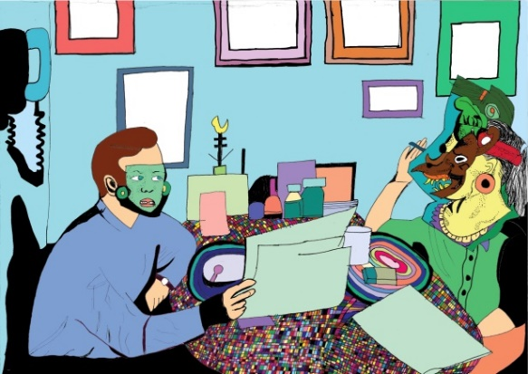
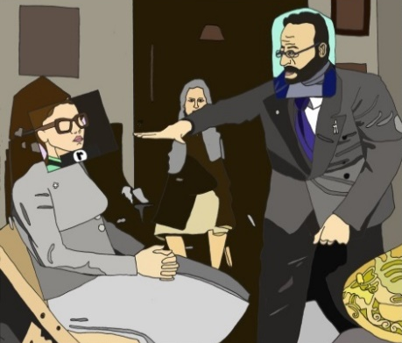

Pathway: Red
Please email Ms Dempsey or Ms Boyle for more information

Note: Students cannot study more than one Art GCSE subject
GCSE Creative Textiles

This course will be awarded as an Art & Design GCSE and therefore the Assessment Criteria is identical.
- Have you ever thought about designing your own clothes?
- Are you aware of current and historical fashion trends?
- Do you enjoy making products? – Can you think creatively?
- Can you solve problems? – Do you enjoy designing?
- Consider investigating new materials? – Would you use/wear and test your ideas?
- Can you work individually and as part of a group?
- Do you like developing decorative techniques?
- Do you have a good imagination?
… then choosing Creative Textiles to study at GCSE could be for you

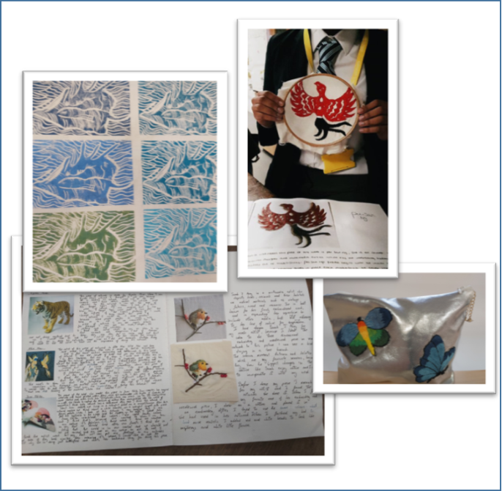
Over two years you will develop a wide range of creative designing and making skills, technical knowledge and understanding relating to textile products and invaluable transferable skills such as problem solving and time management.

The GCSE Creative Textiles course will provide you with the chance to explore and respond to given design brief.

You will be encouraged to explore and encouraged to develop skills in a variety of decorative techniques including applique and printing, image transfer, construction of garments, creating your own patterns and designing accessories and clothing.

You will experiment with varied equipment, processes and technology to develop your design and making skills. You will be required to analyse historical, contemporary and cultural designs and products to support and develop your own ideas.

How is the course assessed?
- 60% coursework made during lessons (3 a week) and 90 minutes’ preparation made in your own time during the week
- 40% Exam, the title of which is given in the January of year 11 and set by AQA. The exam itself is completed over two days
- The sketchbook provides 75% of each project
- The GCSE grades awarded for Art range from 9-1

A strong ability and skill in drawing is integral to the success of the course.

What careers does this course lead to?
Creative subjects have the capacity to unlock alternative ways of learning. GCSE Fashion and Textiles Design is excellent preparation for the study of AS and A’ Level Textiles, Fashion Design and Expressive Arts.
The Creative Industries are the second biggest employer in the UK after finance. Jobs and careers include: fashion designer, merchandiser, stylist, theatre designer, costume designer, fashion buyer, window dresser, footwear designer, pattern cutter, textiles technologist.

Pathway: Red
Please email Ms Longman or Ms Dempsey for more information

Note: Students cannot study more than one Art GCSE subject

GCSE Art Photography

The awarded as an Art & Design GCSE and therefore the Assessment Criteria is identical.

You will experiment with a variety of equipment, processes and technology to develop your ideas using digital cameras and film cameras - including black and white photography in the dark room and digital art. High quality drawing and composition skill will support the planning and development phases of this course.

Photoshop and Apple Macs are also used to manipulate, enhance and present your ideas. You will also be expected to develop your skills with a range of materials. As with the other art options you will explore artists and photographers from a range of cultures; historic to contemporary examples to inspire and develop your own ideas as well as present your personal responses.
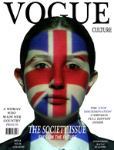

How is the course assessed?
- Coursework 60%
- 40% Exam the title of which will be given in the January
of year 11 and set by AQA.
- The exam itself is completed over two days.
- The sketchbook provides 75% of each project
- The GCSE grades awarded for Art range from 1-9

A strong ability and skill in drawing is integral to
the success of the course.

What careers does this course lead to?
GCSE Photography is excellent preparation for the study of AS and A’ Level Photography, Art, Graphic Design and Expressive Arts.

Examples of career progression related to photography and art could be advertising, photo journalism, designer, digital illustrator, animator and storyboarding, fashion photography, video, television or film production.

Pathway: Red
Please email Ms Boyle or Ms Dempsey for more information

Note: Students cannot study more than one Art GCSE subject

GCSE Music

The GCSE Music course encourages the study of various aspects of composition and performance within the context of a range of musical styles and genres from 1700 to present day.

The Music course is divided into three parts:
Unit 1: Performance – in this unit students develop their performance skills in both solo and ensemble contexts. They rehearse, perform and record two different pieces on the instrument of their choice.

Unit 2: Composing Music – students are introduced to the technical and creative skills required by a composer and are encouraged to explore a range of compositional starting points and ideas for manipulating and developing their own pieces of music.

Unit 3: Music Listening and Appraising – students study a broad range of musical styles and genres in relation to a series of set works. This allows for the development of an appreciation of musical expression and compositional ideas and techniques used by composers throughout history.

How is the course assessed?
- Unit 1 (30%) – in each piece they submit, students are assessed on technical accuracy and musical expression depending on the instrument they choose for performance and the difficulty of the piece. The two performances combined should be a minimum of 4 minutes
- Unit 2 (30%) – students develop musical ideas in the form of compositions and/or arrangements. They must compose two separate and original pieces of music. They must be submitted with appropriate forms of musical notation. The two compositions combined should be a minimum of 3 minutes
- Unit 3 (40%) - this unit is divided into two sections; a listening paper (80 marks) lasting 1 hour and 45 minutes based on the set works studied (8). The new areas of study are: instrumental music 1700–1820, vocal music, music for stage and screen and fusion

What careers does this course lead to?
A GCSE in Music can lead to further study at AS Level or A’ Level in Music (for the study of composition and performance) and advanced courses in BTEC Music and Performing Arts (performance in popular music, music technology and the music business).

It is important to note that GCSE Music is often viewed as complimenting a student’s skills-base (creative, social and communication skills) and adds weight to applications for college and university.

Pathway: Red
Please email Mr Hill for more information
GCSE Drama

The GCSE Drama course teaches you the skills involved in creating and performing Drama and exploring plays written by others. Drama helps you build self-esteem, self-awareness and self-confidence. You will also learn the importance of team-work. You will watch a live theatre performance in the West End as part of the course. You will develop your writing skills to be able to evaluate live theatre and texts. You will study An Inspector Calls as a set text which will also help you with your GCSE English course.

The Drama course is divided into three components:
Component 1: Devising
- You will create a performance in a group based on a given idea or theme
- You will create a portfolio of evidence of the rehearsal process
- This can be written, or recorded

Component 2: Performance of a text
- You will rehearse and perform two extracts from a script to a visiting examiner

Component 3 Theatre Makers in Practice
- You will have a written exam based on the study of a set text and answering questions on an unseen text
- You will write an evaluation of a live theatre performance seen during the course and written using performance notes in the written exam

How is the course assessed?
- The course is assessed through a combination of a 40% written exam and 60% practical work with portfolio evidence
- The portfolio can be recorded as well as written or a combination of both

Pathway: Red
Please email Ms Lawrance for more information

GCSE Food Preparation & Nutrition

Examination Board: WJEC/ Eduquas
What will I study?
- Food Commodities
- Principles of nutrition
- Diet and health and
- The science of food
- Where food comes from
- Cooking and food preparation

What skills will I develop?
- How to prepare and cook a variety of different foods
- To carry out effective and safe cooking using a range of equipment
- Understand the different properties of food
- How to nutritionally analyse foods
- How to make informed food choices
- How to research and analyse
- To be able to critically evaluate
- Develop recipes and meals to meet specific needs

How will I be assessed?
- Unit 1: Principles of Food Preparation and Nutrition – written examination (1hr &45 mins) 50%
- Unit 2: Food Preparation and Nutrition in Action which is divided into two assessment tasks includes a 3 hour practical – 50%

Food Preparation and Nutrition is suitable for you if you enjoy:
- Cooking and learning about food
- Practical tasks where you can work independently to produce coursework tasks
- Finding out about traditional food and international cuisine
- Understanding the scientific principles about food and how it affects the body

Why should I study Food Preparation and Nutrition?
To equip you with the knowledge, understanding and skills required to cook and apply the principles of food science, nutrition and healthy eating. It encourages you to cook, enables you to make informed decisions about food and nutrition and allows you to acquire knowledge in order to be able to feed yourself and others affordably and nutritiously, now and later in life. It allows you to study at A level, Further Education or enter an apprenticeship.

Pathway: Red
Please email Mr M Smith for more information

BTEC Work Skills

Aims of the Course
The purpose of this course is to equip you with the skills to obtain employment and build confidence so that you can successfully find and retain jobs and improve your life chances.

Why study BTEC Work Skills?
Within this course you will develop a wide range of skills which will be useful both in your studies and for your progression once you leave school. As well as developing skills needed for employment you will learn how to manage your finances, develop and demonstrate enterprise skills, build effective communication skills and learn how to solve a variety of problems.

Course Breakdown
In order to achieve the qualification, you have to successfully complete minimum of 13 credits worth of units. Each of these units is assessed through coursework (role plays, interviews, creating and delivering presentations, creating wall displays, producing guides and working with others). The units and their credit ratings are listed below:

Units | Title/Description | How will it be assessed? | Towards final grade
11 | Working in a team | Coursework | 30 hours
22 | Self-assessment | Coursework | 10 hours
13 | Personal behaviour for success | Coursework | 30 hours
1 | Produce a CV | Coursework | 20 hours
3 | Achieving success at interview | Coursework | 15 hours
2 | Applying for jobs | Coursework | 15 hours
23 | Self-management for work | Coursework | 12 hours

Progression routes available after the course
One of the great things about this course is the fact that the skills you develop through its completion are appropriate to any career you may choose. You will have an improved understanding of how to successfully apply for jobs and how to work with others in an organisation to give you the best chance of having a job for life. You will also learn and develop skills such as managing money, using ICT and effective communication. (There may be the opportunity in some situations for students to attempt the BTEC Level 1 Extended Certificate in Work Skills which requires successful completion of 13 credits).

Web link/address to syllabus http://www.edexcel.com/quals/workskills/Pages/default.aspx

Pathway: Green
Please email Ms Codrington for more information

Functional Skills English

Functional Skills English gives you practical skills for the modern world and helps you get the most from life, learning and work.

This course aims to ensure you have good communication skills in reading, writing, speaking and listening. It assesses whether you can use these skills in everyday situations.

Often a student's first accredited qualification in English (as a second language); this course can be used in preparation for GCSE. It is suitable for a wide ability range. There are no prior learning requirements for this pass/fail qualification.

Based on a range of relevant, real-life texts, contexts and scenarios, Functional English reflects today's challenges.

Tasks may involve:
- Reading leaflets, reports or articles
- Writing letters, emails or notices
- Taking part in discussions and giving presentations

Structure
Functional English comprises:
- Reading
- Writing
- Speaking, listening and communication

You will sit exams for every skill mentioned above.

These qualifications are designed to help you succeed in higher education or any job role, since strong English skills are essential in almost every context of work and higher education.

You will be invited to join this course.

Pathway: Green
Please email Ms Miron for more information

Red Pathway
This pathway is suitable for the majority of students. It is recommended that students choose red subjects. Please note that Business and ICT vocational are green as well as red subjects. If students have a real passion for one of the blue or green subjects there is flexibility here too, please email those subject teachers or a member of the year team to discuss this.

Blue Pathway
This pathway provides opportunities for stretch and challenge for our most able students. Although all of the GCSE courses will provide challenge, it is recommended that students on the blue pathway choose red subjects but consider choosing at least one blue subject as well.

Green Pathway
This pathway is for more vocationally minded with an emphasis on ‘quality not quantity’. It is recommended that students choose green subjects but if students have a real passion for a particular subject there can be flexibility here. This will be judged on an individual basis. Please email those subject teachers or a member of the year team to discuss this.

Completing Options Forms

Pathway Information

You will be sent a digital Options Form to complete via the MyEd app. It is vital that you complete this form carefully and submit it by the 5th March deadline.

If for any reason you are unable to complete the digital copy, you can collect a paper copy from the school’s reception to complete and return by the deadline.

Option choices should be made in conjunction with your child’s recommended pathway (of which you will have already been informed) and the options form on the final page of this booklet, which provides further information to consider. Once you have read through the options form with your child, you should choose one option and one reserve* option from each of the three option blocks, then transfer this information to the digital form once it is made available to you.

If you have any difficulties with this process or have any questions, please get in touch using the following email address: options@kelmscott.waltham.sch.uk

*We endeavour to allocate every student their first option choices, however where this is not possible, their reserve
options will be considered.

KEY STAGE 4 OPTIONS FORM 2021
I am considering doing the following jobs and careers:
_________________________________________
_________________________________________
_________________________________________

NAME: ____________________________________ FORM: __________ PATHWAY:

- English Baccalaureate subjects (indicated in the option blocks as bold*)
- Computing counts as a science in the English Baccalaureate list of subjects; this means that students choosing Computing will also need to do a humanities and language subject if they want to complete the FULL English Baccalaureate.
- ALL students (unless on a green pathway) MUST choose at least 1 Ebacc subject across the 3 option blocks

- Broadening subjects (indicated in the option blocks as underlined)
- It is recommended that all students choose a ‘broadening subject’

- You cannot study two GCSE Art subjects  - Some students will be directed to do Additional English or Work Skills  - Students choosing subjects that are similar in content (as shown in the next list) may be asked to choose alternative subjects  - Students doing ICT Vocational (unless on green pathway) in Block 3 must pick at least 1 Ebacc subject | Students are advised not to overspecialise by choosing the following combinations:  - Business Studies GCSE and/or Business Vocational and/or Economics GCSE  - Computing GCSE and ICT Vocational  - Engineering GCSE and DT GCSE  - History and Ancient History  If you pick these combinations you will be asked to choose another subject

- Tick one course in each of the option blocks below (1, 2 & 3)
- You must also select one reserve choice from each block, write R next to your reserve choice in blocks 1, 2 & 3
PATHWAY |  |  | BLOCK 1 | ✔/R |  | PATHWAY |  |  | BLOCK 2 | ✔/R |  | PATHWAY |  |  | BLOCK 3 | ✔/R
 |  |  | Business Studies GCSE |  |  |  |  |  | Art & Design GCSE |  |  |  |  |  | Art Photography GCSE
 |  |  | Business Vocational |  |  |  |  |  | Computer Science GCSE* |  |  |  |  |  | Business Studies GCSE
 |  |  | Creative Digital Art |  |  |  |  |  | Creative Textiles GCSE |  |  |  |  |  | Computer Science GCSE*
 |  |  | Drama GCSE |  |  |  |  |  | Design & Technology GCSE |  |  |  |  |  | French GCSE
 |  |  | Engineering GCSE |  |  |  |  |  | Economics |  |  |  |  |  | Functional Skills English
 |  |  | Food Preparation & Nutrition GCSE |  |  |  |  |  | Geography GCSE* |  |  |  |  |  | Geography GCSE*
 |  |  | French GCSE* |  |  |  |  |  | History (Modern) GCSE* |  |  |  |  |  | History (Modern) GCSE*
 |  |  | Geography GCSE* |  |  |  |  |  | Information Technology Vocational |  |  |  |  |  | Information Technology Vocational
 |  |  | History (Ancient) GCSE* |  |  |  |  |  | Latin GCSE* |  |  |  |  |  | Music GCSE
 |  |  | Physical Education GCSE |  |  |  |  |  | Spanish GCSE* |  |  |  |  |  | Spanish GCSE*
 |  |  | Study Support |  |  |  |  |  | Work Skills BTEC |  |  |  |  |  | Triple Science*
 |  |  | Triple Science* |  |  |  |  |  | INTENTIONALLY BLANK |  |  |  |  |  | Urdu GCSE*
 |  |  | INTENTIONALLY BLANK |  |  |  |  |  | INTENTIONALLY BLANK |  |  |  |  |  | INTENTIONALLY BLANK
Student’s Signature: _______________________________________
Forms must be submitted by the 5th March deadline
Parent/Carer’s Signature: ___________________________________

